CONTINUE THE JOURNEY
Leadership & Prayer Resource Recommendations
Calvary Temple Leadership Development Workshop | September 19, 2026
Recommended path: formation of the leader -> prayer -> shared ministry -> mission.

Core Workshop Books
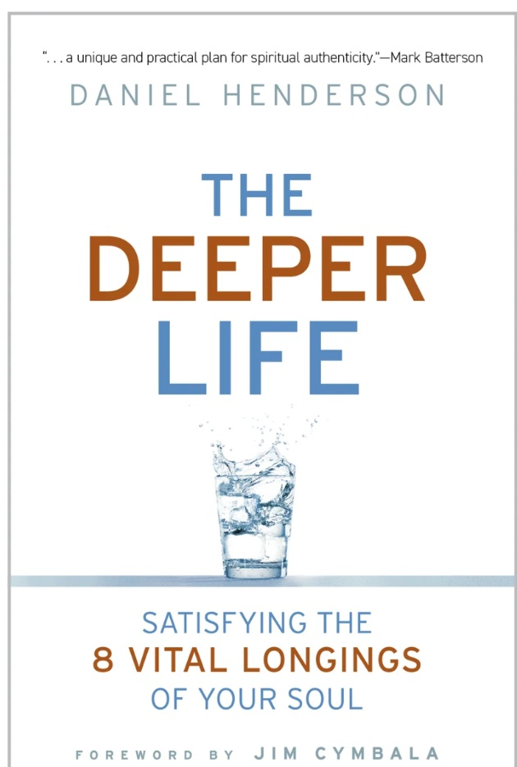  The Deeper Life  Daniel Henderson  Begin here: theology, identity, purpose, values, priorities, goals, time, and legacy.   | 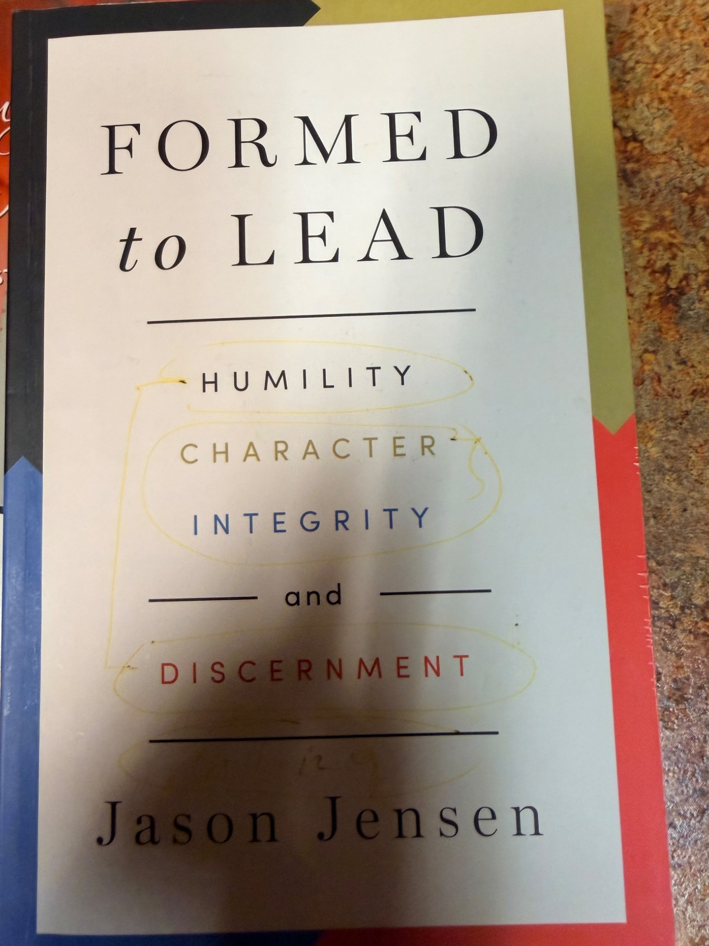  Formed to Lead  Jason Jensen  Christian leadership formation through humility, character, integrity, discernment, and prayer.  

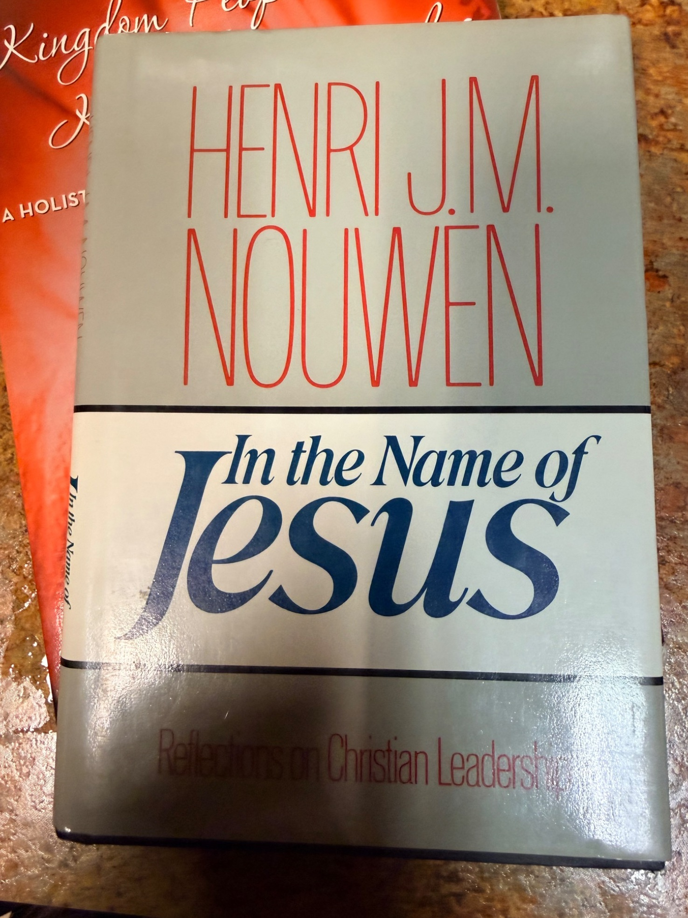  In the Name of Jesus  Henri J. M. Nouwen  A concise call to Christ-centered leadership shaped by prayer, mutuality, service, and dependence on Jesus.   | 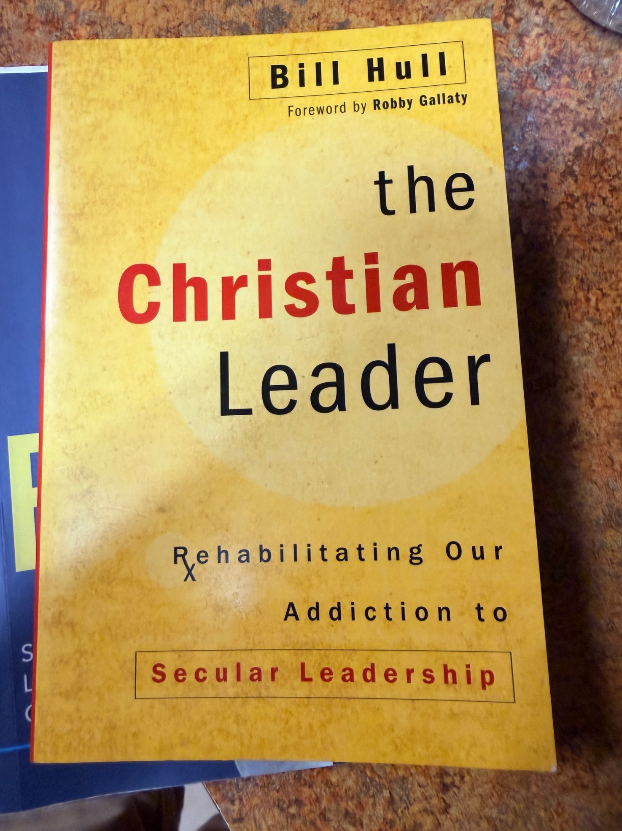  The Christian Leader  Bill Hull  A biblical critique of secular leadership assumptions and a call back to disciple-making leadership.  

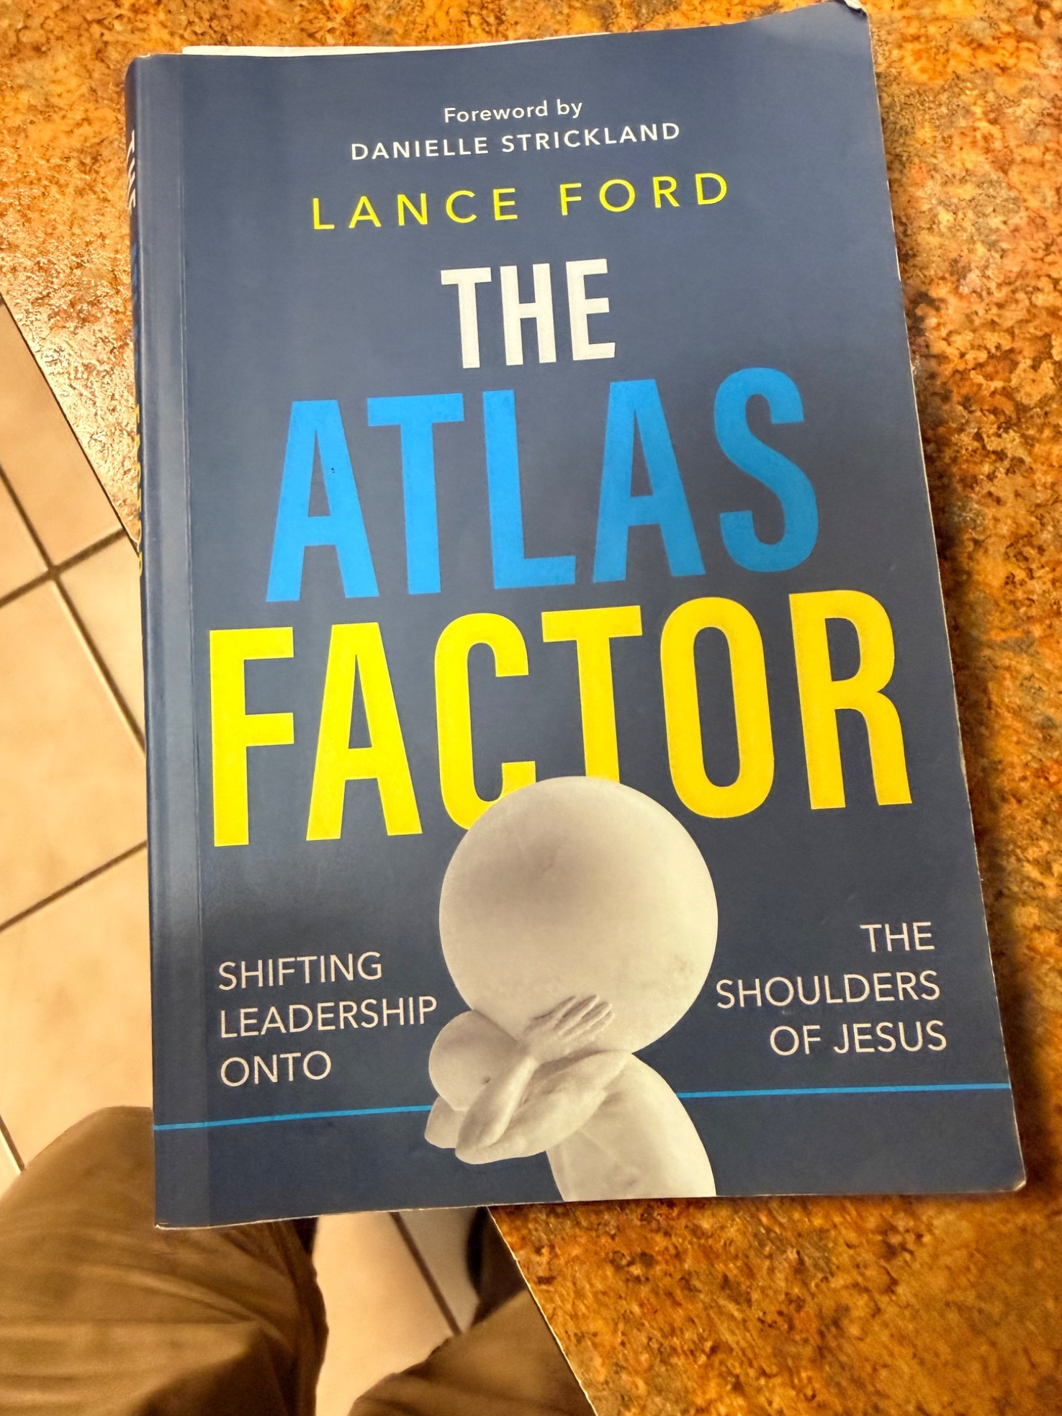  The Atlas Factor  Lance Ford  Shared ministry, healthier authority, and shifting the burden of leadership onto the shoulders of Jesus.   | 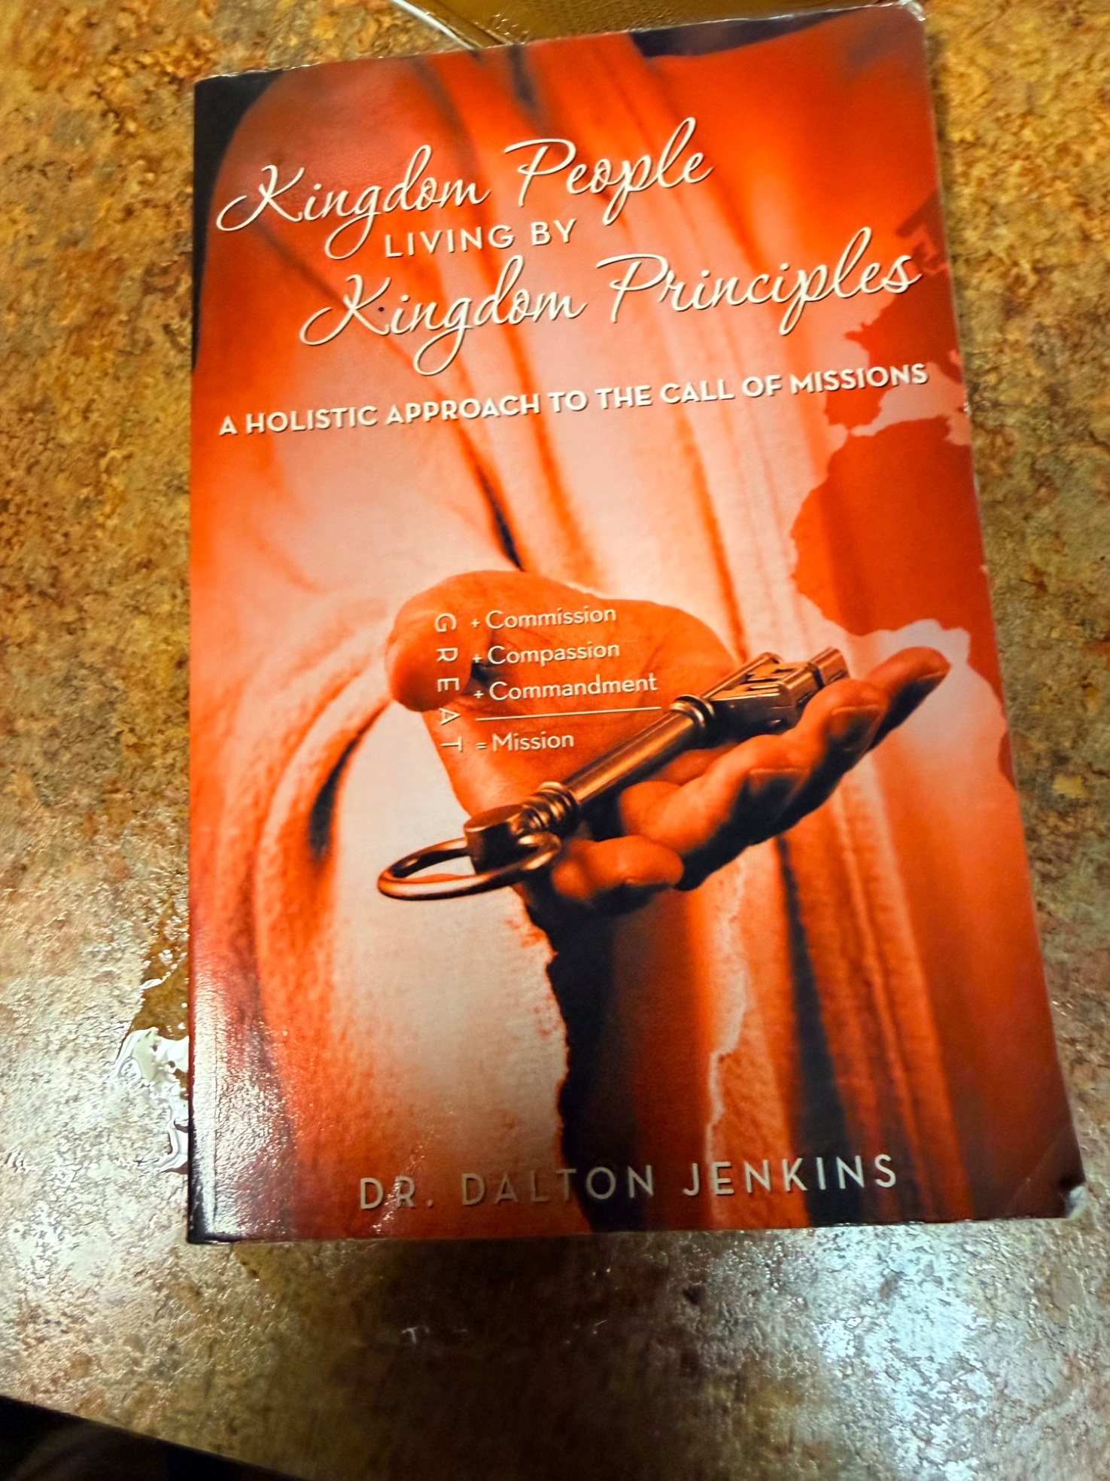  Kingdom People Living by Kingdom Principles  Dr. Dalton Jenkins  Great Commandment + Great Compassion + Great Commission = Great Mission.  

How These Books Serve the Workshop
PILLAR I - Characteristics of a Christian Minister
The Deeper Life, Formed to Lead, and In the Name of Jesus focus on the leader before the task: identity, character, humility, prayer, integrity, discernment, and Christ-centered service.
PILLAR II - Building Morale in the Church Community
The Christian Leader, The Atlas Factor, and Kingdom People help leaders evaluate church culture, shared ministry, trust, participation, and mission beyond the four walls.
Keep prayer underneath the entire leadership journey, not beside it.

Strategic Renewal / 6:4 - Books for Prayer & Leadership Formation
Prayer is foundational, not an additional program. These resources reinforce the workshop emphasis on seeking God, Acts 6:4, healthy leadership, and building a praying church culture.
The Deeper Life  Daniel Henderson  Start with the person before the ministry role. | 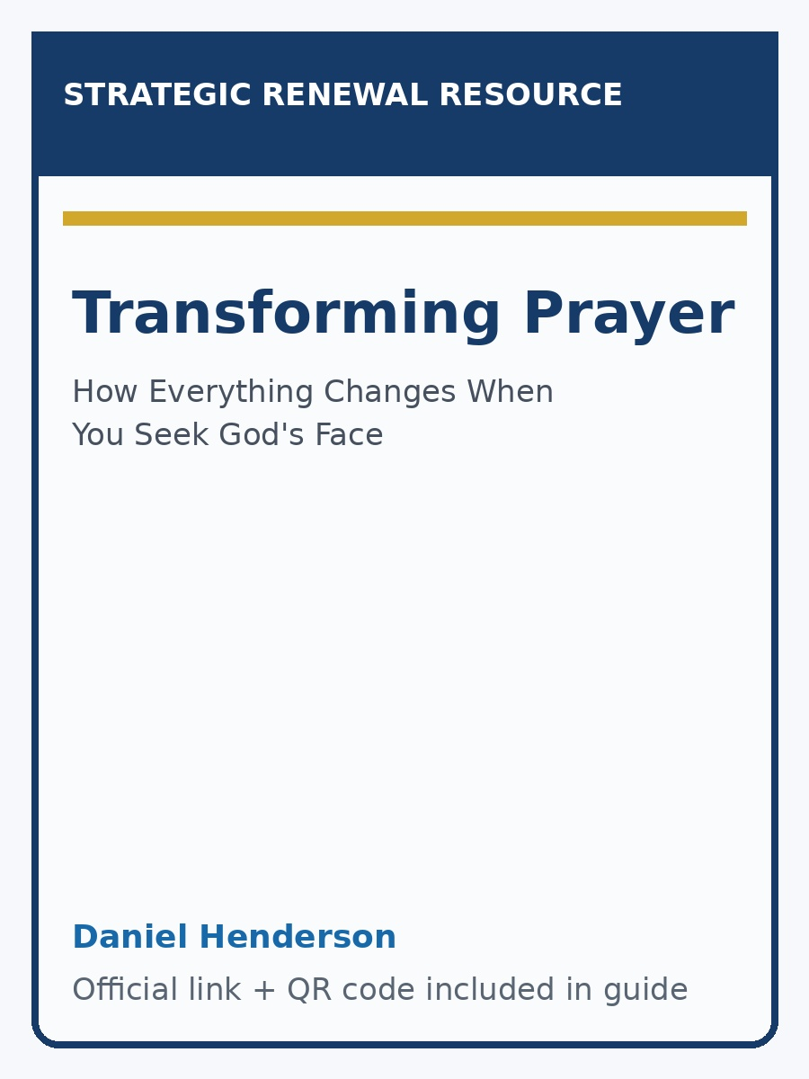  Transforming Prayer  Daniel Henderson  Scripture-fed, Spirit-led, worship-based prayer and seeking God's face.  

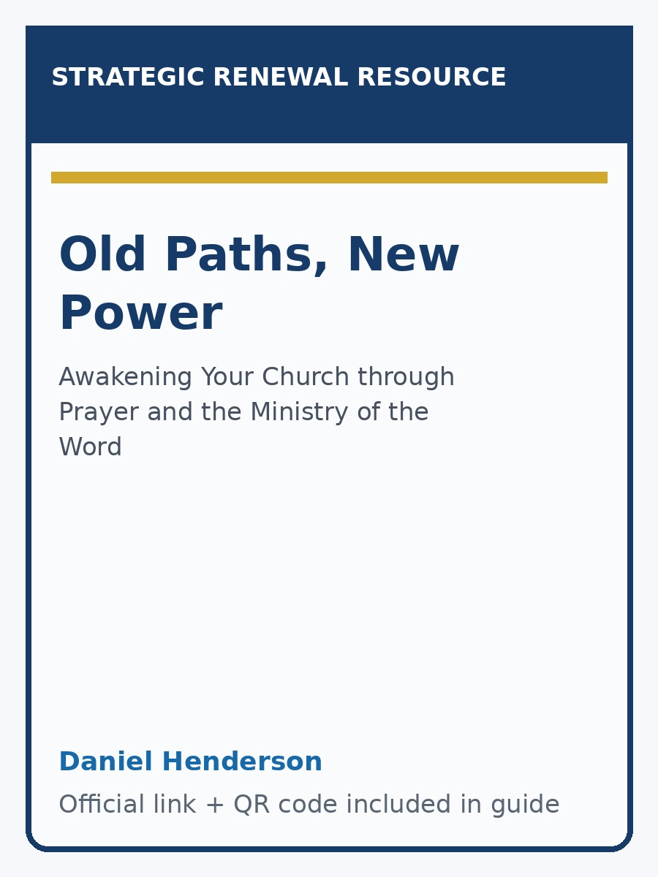  Old Paths, New Power  Daniel Henderson  Acts 6:4: prayer and the ministry of the Word as the church's central ministry pattern.   | 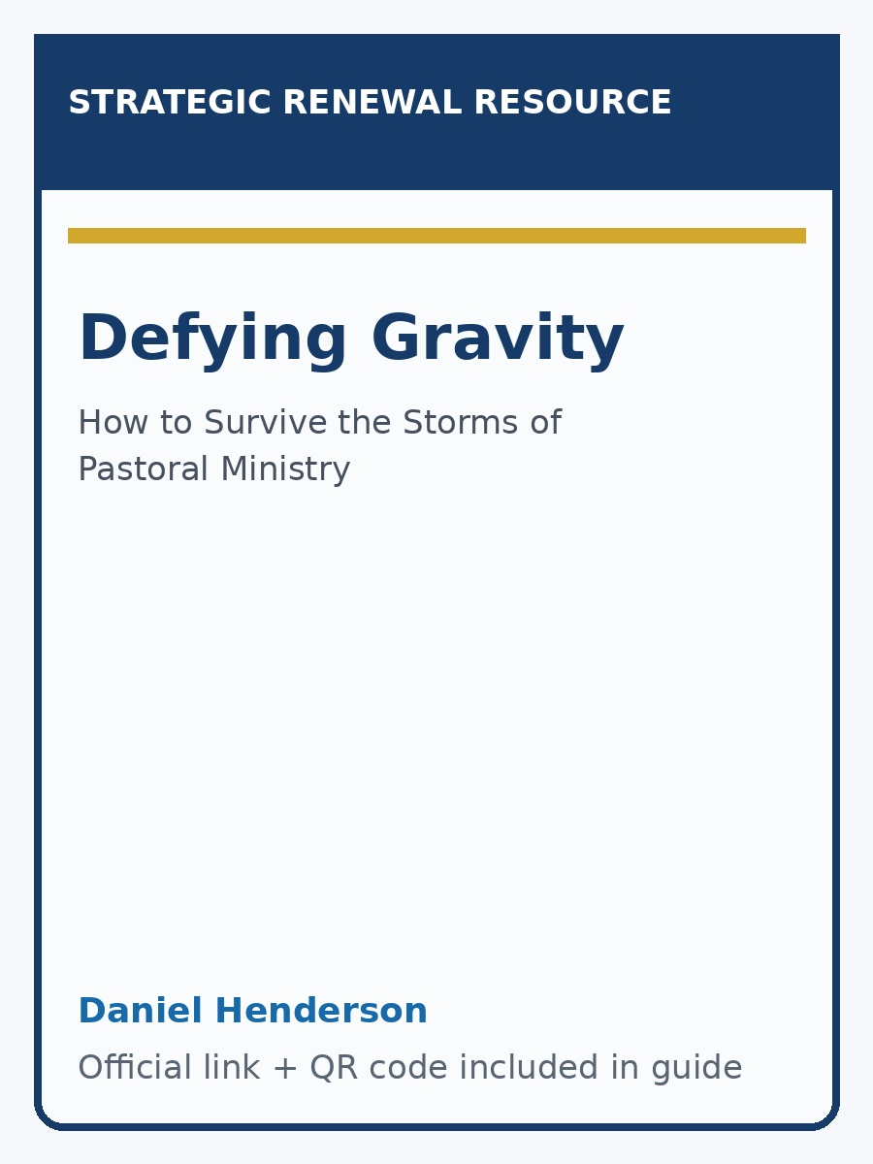  Defying Gravity  Daniel Henderson  Pastoral and leadership health; the source book behind the nine leadership gauges.  

Note: The Deeper Life image is an actual cover. The other Strategic Renewal entries use self-contained resource cards so the guide displays reliably offline; scan the QR codes for the official product pages and cover artwork.

Strategic Renewal / 6:4 Follow-Up Resources
Prayer That Changes Us  The transforming power of seeking God's face before simply seeking His hand. | 

The Praying Leader: 90 Days That Transform a Pastor  A pathway toward deeper intimacy with God, renewed focus, and a praying-church culture. | 

Prayer Guide: Developing Praying Leaders  A practical pattern: REVERENCE -> RESPONSE -> REQUESTS -> READINESS. | 

9 Gauges to Assess Your Leadership Health  A 1 Timothy 4:16 framework for truth, integrity, intimacy, identity, accountability, family, pain, and calling. | 

Suggested Reading Path
1. The Deeper Life - personal alignment and spiritual identity.
2. Formed to Lead + In the Name of Jesus - character and Christ-centered ministry.
3. The Christian Leader + The Atlas Factor - leadership culture and shared ministry.
4. Kingdom People - reconnect leadership and morale to mission.
5. Strategic Renewal / 6:4 resources - keep prayer and the ministry of the Word at the center.
LEAD WELL • LOVE WELL • SERVE WELL

